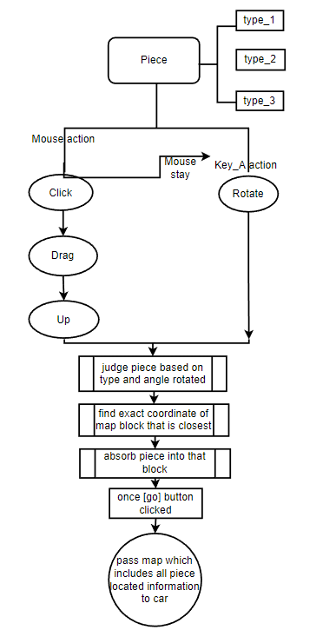

Description of car path generation and movement

Algorithm logic description:

Car class contains car instance generation and path drawing, the key class methods are **getOutPoint, getInPoint, getNextPieceX, getNextPieceY, paintPath, pathSegament**.

1. getOutPoint

Method presets entry and exit points for all puzzle types and initializes different two-dimensional arrays by passing in different types.

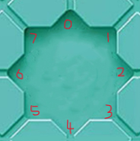

All the import and export numbers are shown in the picture.

Method getOutPoint flow chart

1. getInPoint

Calculates the in point of the previous function by passing in the out point of the present function and returns the value.

public int getInPoint (int outPoint){return (outPoint + 4) % 8;}

1. getNextPieceX

Function parameters are the current puzzle coordinate x and exit point value, return the next puzzle should arrive at the X coordinate.

public static int getNextPieceX(int X, int outPoint){  
 int i = 0;  
 if(outPoint==0||outPoint==4){i = X;}  
 if(outPoint==1||outPoint==2||outPoint==3){i= X+1;}  
 if(outPoint==5||outPoint==6||outPoint==7){i = X-1;}  
 return i;}

1. getNextPieceY

Function parameters are the current puzzle coordinate y and exit point value, return the next puzzle should arrive at the Y coordinate.

public static int getNextPieceY(int Y, int outPoint){  
 int i = 0;  
 if(outPoint==2||outPoint==6){i = Y;}  
 if(outPoint==0||outPoint==1||outPoint==7){i = Y-1;}  
 if(outPoint==3||outPoint==4||outPoint==5){i = Y+1;}  
 return i;}

The return value can be moved horizontally, vertically, or diagonally.

1. paintPath

Receive four parameters, the X and Y coordinates of the puzzle, and the type of the puzzle and the exit point after rotation. Draw different types of curves using different types of puzzle types, such as QuadCurveTo, LineTo, and ArcTo.

1. Pathsegament

